

MANUAL 2:

*Service Cycle Management*

10/26/2011

ISC

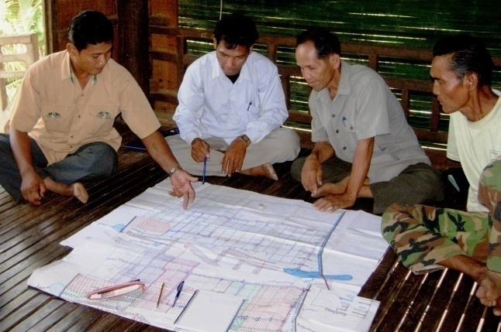

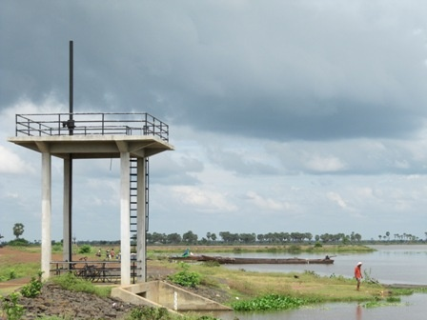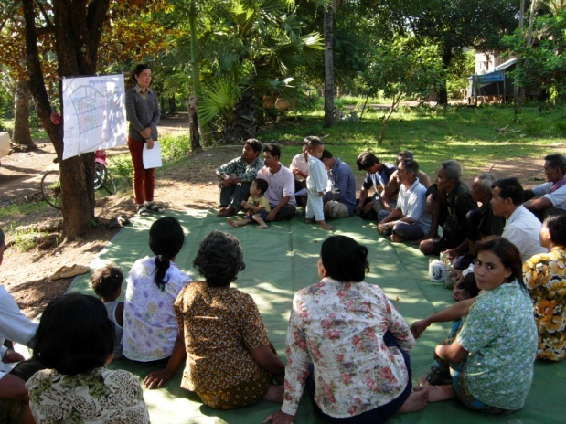

Manual 2: Service Cycle Management

# Presentation and objectives of this manual:

Present the tools that are used throughout the service cycle for identifying new customers, negotiating and following-up contracts and monitoring services and FWUC.

## The service cycle

The ISC has developed a full process for contracting services in three phases:

### Scheme identification and assessment

The purpose of this phase is to get clear information about new schemes where the ISC has never worked.

* 1. **Short assessment and selection:** the team collects data from the FWUC and local authorities and visits the scheme infrastructures in order to get a first look about its current condition. The information collected might be incomplete, but shall allow the team to get an idea if there is a possibility to provide support, to improve the scheme functioning or not.
  2. **Detailed study and mapping:** if the scheme shows some potential for improvement and has been selected after the short assessment, the ISC team will collect data more systematically, visit all villages and draw the scheme on a sketch map with information about infrastructures, serviced area, problems, farmer proposals...
  3. **Intervention strategy design:** the results of the detailed study are discussed within the team to design an overall approach to the future services: which steps shall be followed for improvement, which kind of supports shall be prioritized.

At the end of this phase, the ISC team will have enough knowledge about the irrigation system to be able to discuss a service proposal with the local stakeholders.

### Service and contract negotiation

Before any support is provided, the ISC team must validate a service proposal and sign a contract with the local stakeholders.

1. **Study and strategy presentation:** one or several meetings are organized with the FWUC representatives and the local authorities to present the results of the study and the general strategy proposed, so that there is an overall understanding and agreement on which supports are needed to improve the scheme management and a first step or service is prioritize.
2. **Formal service proposal:** Based on the decisions made during the previous meeting, the ISC team prepares a detailed service proposal including all activities, expected outputs, staff mobilization plan and budget. This proposal is presented, discussed and approved by the FWUC representatives and / or the local authorities.
3. **PDOWRAM and local authorities’ approval:** Before implementation, the FWUC representatives and the ISC team meet with PDOWRAM and other relevant government agents to inform about the work that will be done, to validate the service and get an official recognition of the ISC intervention, best up to district and provincial levels.
4. **Contract agreement:** Once all has been approved, a service contract is written, including a budget and all parties’ responsibilities for implementation and payments.

### Service implementation and monitoring

1. **Service implementation:** After signing the contract, the team can be mobilized for the service. All activities have to be result oriented.
2. **Process follow-up:** All meeting and inputs are recorded to ensure the proper implementation according to the service proposal and the number of working days on the contract for each staff is recorded.
3. **Service evaluation by farmers:** Once the service is finalized, the outputs are evaluated and validated by the FWUC committee and presented to the farmers.
4. **Contract payment:** If the evaluation is positive and approved, the ISC send an invoice and the FWUC pays the service.

At the end of one service, the ISC can propose a new service according either to the request from the FWUC or after a FWUC management evaluation.

# Chapter 1: Potential customer assessment

## Quick assessment

### Methodology

* Consult CISIS database
* Meeting with commune and FWUC representatives
* Visit the field with village chief and farmers
* Group meeting
* Short meeting at district and PDOWRAM level

### Goal and general questions

*Goal = to assess the possibility of collaboration between the FWUC (or farmers) with the SC*

1. Does the scheme is still functioning?
2. How does it work? (Source of water, storage, distribution)
3. What is its performance in term of agriculture?
4. What is the collective or private organization around the infrastructure?
5. How far farmers are part of negotiations and decision making?
6. How coordination between stakeholders is organized?
7. Does the scheme is functioning well in term of equity (access to land and to the water)?
8. What is the current economical interest of the farmers in using this scheme and their future expectations?
9. What are the steps to improve the scheme management according to farmers?

### Assessment form

|  |  |
| --- | --- |
| **SCHEME NAME** |  |
| Assessment date:  Team: |  |
| 1. **Scheme location** |  |
| Province / District |  |
| Commune(s) |  |
| Village(s) / Population |  |
| Access to scheme |  |
| **2. Scheme description (include a sketch map)** | |
| Irrigation system type  - Main  - Secondary  - Distribution system  - Drainage system |  |
| Existing main infrastructures  *Actual state and functioning* (%) |  |
| Command area (ha) |  |
| **3. Irrigated area and farmers** |  |
| Irrigated and cultivated area / season / cropping system |  |
| %age of irrigated area / real command area |  |
| Number of   * + - Landowners     - Farmers accessing water |  |
| Data source |  |
| Basic estimate or clear record? |  |
| **4. Scheme history** |  |
| Period of initial creation / origin by whom |  |
| Public / Internat'l / Private supports: agencies / dates |  |
| Big damages / conflicts / events in the past |  |
| **5. Irrigated crop economic result** |  |
| Main crop |  |
| Average quality of soil |  |
| Intensive or extensive cropping methods |  |
| Yield range |  |
| Local paddy price at farm level |  |
| Labor price in the area (transplanting / harvesting) |  |
| Estimated average income for one hectare per season |  |
| **6. Present and actual roles & responsibilities carried out by local stakeholders for O&M** | |
| Farmers (FWUC or informal) | |
| Commune and other local authorities | |
| PDOWRAM | |
| Private service provider | |
| Other = | |
| **7. FWUC organization** |  |
| Date of creation |  |
| Promoter |  |
| Membership registration |  |
| Membership fee |  |
| Member list  Plot database |  |
| Last election date  Election procedure (open or ballot)  Participation to election (record?) |  |
| Existing Statutes / Internal rules / By laws |  |
| Registration level |  |
| Village / General assemblies |  |
| Last assembly dates  Participation to the last assembly |  |
| Relations with users and members (Nil / Rare / Sometimes / Frequent) |  |
| **8. ISF / budget** |  |
| Budget plan |  |
| Total annual/seasonal budget amount |  |
| Official ISF level(s) |  |
| How ISF level is fixed? |  |
| ISF collected record list or database |  |
| Last collection period |  |
| Collection level (%age) |  |
| Total amount collected |  |
| Other income sources / amount |  |
| Financial procedures:   * + - Book keeping     - bank account |  |
| Type of expenditures (salary, work, etc.) |  |
| **9. Operation and water management** |  |
| Operation plan and rules |  |
| Service definition |  |
| Gate operators |  |
| Existing conflicts for water sharing |  |
| Coordination between users from the same source of water |  |
| **10. Maintenance** |  |
| Last maintenance works done |  |
| Annual maintenance budget |  |
| Maintenance planning process |  |
| Maintenance quality |  |
| Maintenance under MOWRAM responsibility |  |
| **11. Internal rules enforcement** |  |
| Existing rules and regulations |  |
| Level of enforcement |  |
| Conflicts |  |
| **12. Local stakeholder appreciation** |  |
| Main problems / conflicts faced |  |
| Main solutions proposed |  |
| Main needs in term of rehabilitation |  |
| Main needs in term of management improvement |  |
| Farmers interest for improvement | |
| Commune interest for improvement | |
| **13. Comments / other descriptions** |  |
|  |  |

### Scheme typology

How to define the water service

|  |  |  |
| --- | --- | --- |
| System type | Description | Water service depending on |
| 1. Reservoir | Storage of water from runoff or stream and distribution according to needs | * + - Storage capacity and renewal     - Level of distribution channels and control structures     - Drainage system |
| 1. Diversion weir | A dam or a weir across a river bed allows to divert its water to distribution channels (no or low storage capacity) | * + - Stream water level variation     - Level of distribution channels and control structures     - Drainage system |
| 1. Flood recession reservoir | Reservoirs in the flood plains of Mekong and Tonle Sap, filled during flood and irrigating during recession period | * + - Storage capacity |
| 1. Colmatage canal / *Prek* | Canal through a river embankment for spreading flood to the fields | * + - Flood variations (except if associated with pumping system)     - Level of distribution channels and control structures |
| 1. Runoff control dam | Dam to prevent excessive drainage in the upstream area | * + - Runoff variation     - Upstream fields height / slope |
| 1. Flood protection dam | Dam along a stream to prevent floods | * + - Flood variation |
| 1. Drainage canal | Canal for increasing lowland drainage capacity | * + - Runoff and flood variation |
| 1. Polder | Dam and drain system for avoiding seawater intrusions and managing water level inside polders | * + - Drainage capacity |
| 1. Pumping system | Pumping stations  Mobile pumps | * + - Water source renewal     - Mobility     - Capacity and consumption     - Fuel cost |
| 1. Micro-irrigation | Hand pumping  Drop systems  Traditional buckets and noria | * + - Water source renewal     - Investment intensive     - Labor intensive |

### Scheme size definition

MOWRAM consider three scheme sizes according to [command area]:

* **Small:**  less than 200 ha
* **Medium:** over 200 ha and less than 500 ha
* **Large:** over 500 ha

Sometimes the category of **very large** schemes, over 5,000 ha is added.

The irrigated area can be estimated or calculated according to various references which should not be mixed:

|  |  |
| --- | --- |
| **Command area** | Total area of land which is lower to a canal or reservoir water level |
| **Equipped / Serviced area** | Area where the water can be brought thanks to canals and structures |
| **Potential irrigated area** | Area of land which can potentially receive sufficient and reliable water according to the water source and the crop requirements / season |
| **Real / actual irrigated area** | Area of land which actually receives some irrigation water according to farmers practice / crop / season (no mention of sufficiency, nor reliability) |

#### Cropping systems

It is not the point here to review the Cambodian agricultural systems as a whole, but to present certain characteristics of the cropping systems useful for the description of irrigation systems. The major cropping systems in Cambodia can be described by taking account of four criteria: the crop type, the season, the crop cultivation length and the inundation feature of the area.

The major irrigated crops are rice and fresh vegetables (including corn mainly for fresh consumption). Other crops are nearly non–existent in irrigated areas. The vegetables can be grown year round, but they are mostly grown during the dry season when water recedes. Vegetables are grown in irrigated areas with fertile soils and full water control allowing a nearly daily watering. In most of the lowland irrigated areas, inundation can be fully controlled only during the dry season.

The seasons are often described as two: the wet season from May to October and dry season from November to April, but regarding rice cropping, it is useful to distinguish further between:

* early wet season (March to August)
* normal wet season (June to December)
* late wet season (September to January)
* early dry season (November to February)
* normal dry season (January to June)

The early wet season rice cultivation needs supplementary irrigation during the first months. Sometimes farmers take advantage of the first heavy rains in April for plowing. They mostly grow a short term variety followed by a second cultivation cycle with either a short or a medium term variety during the late wet season. Some may wish to skip the wet season for the second crop and cultivate rice during the early dry season in order to avoid insect problems during the normal dry season and to still benefit from the late rains.

The length of the growth cycle of different varieties is also fundamental. Farmers often distinguish between:

* short term varieties (modern, high yielding): cycle of 90 to 120 days (*srov sraal*, “light rice”)
* Medium term varieties: cycle of 120 to 150 days (*srov kandal*, “middle rice”)
* Long term varieties: cycle over 150 days (*srov thnguon*, “heavy rice”)

Short term varieties are grown all year round, but especially during the dry season and the early and late wet season. Medium and long term varieties are grown during the wet season only.

In areas affected by deeper inundation during some period of the year, farmers grow two different types of long term varieties:

* Deep water rice (*srov teuk chomrov*) 0.5 to 1 m high varieties
* Floating rice (Srov laeng teuk): over 1 m long

Long term and very long term varieties are grown in the field where the inundation is too deep for other varieties. These areas are the flat lands around the Tonle Sap lake and near the Mekong river.

Long term varieties are harvested late December and January preventing farmers within an irrigated area to grow a second crop during the early dry season if they want to avoid high insect damages. This is one reason why stored water in some schemes is not used during the dry season. The farmers fear the failure of a late dry season crop and don’t want also to shorten the cycle of their wet season rice by fear of inundations.

In some irrigation systems, farmers have found more attractive to develop double wet season cropping by starting earlier. The problem of early wet season cropping is the potential conflict between farmers harvesting in August and asking to drain their fields when other farmers want to keep water in their transplanted fields following a normal wet season cycle. A common cultivation calendar has to be respected by all farmers within one block depending on the same control system. The other advantage of early wet season is the lower water requirement (~8,000 m3/ha) due to more rainfall. If the storage capacity of the reservoir is limited, farmers may prefer to cultivate during the early wet season, quantity of irrigation water required per hectare is reduced and the reservoir is refilled by early rains.

Double wet season cropping is rarely mentioned as a way to valorize irrigation water. In many instances, securing wet season cropping is the main expectation of farmers in irrigated area.

A high percentage of the dry season irrigated areas in Cambodia are not grown during the wet season, at that moment they are flooded by the water of the Mekong river and the Tonle Sap lake. The crops are grown when water recedes, the so-called “recession rice”. Receding rice (*srov pradenh teuk*) or vegetable cropping can rarely be sustained without supplementary irrigation. Most of these recession crops are irrigated by lake flooding reservoirs and pumping system.

### Rice cropping calendars

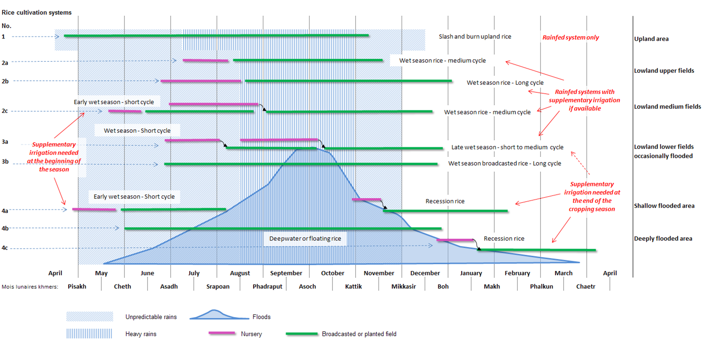

### Scheme selection criteria

After collecting information through the quick assessment the team shall consider the following criteria for selecting new potential customers and going further for the study

1. Within the targeted provinces
2. Partially functional infrastructures & reliable water source
3. Existing FWUC or farmer organisation in charge
4. Demand from farmers and/or local authorities
5. Sufficient agricultural and economic potential
6. No serious conflict
7. Support from local authorities (including financial)
8. Good potential for improvement
9. Financial means to pay services

The weight given to these criteria rests upon the team according to opportunities

## Detail diagnosis

## FWUC management evaluation (Arrow) just few words

# Chapter 2: Contract Management

## Service proposal and negotiation

## The contract

## Time sheet follow-up



## Datasheet

**DATA SHEET FOR ACTIVITY FOLLOW-UP**

*Each time one ISC staff is meeting with farmers, representatives, local authorities or others in the framework of their work, they should fill this data sheet to help to keep a trace of their activity and facilitate reporting.*

Donor / Funding for this activity: AFD EU Other: …………………………………..

Level of the meeting:

|  |  |  |  |  |  |
| --- | --- | --- | --- | --- | --- |
|  | National |  | Provincial | District | Commune |

Related service contract if any: ……………………………………………………….

Place and / or Irrigation scheme :

Date: ……………………………………….. Duration: ……………………………………………

Thematic:

ISC staff in charge: ……………………………………….. ISC staff present: …………………………………………………….

Category:

|  |  |  |  |  |  |
| --- | --- | --- | --- | --- | --- |
|  | Survey |  | Official meeting |  | Contract negotiation |
|  | Coaching |  | Formal training |  | Exchange visit |
|  | Construction follow-up |  | Team building |  | Workshop |
|  | Other …………………………….. |  |  |  |  |

|  |  |  |  |
| --- | --- | --- | --- |
| **Public and participation:** | **Men** | **Women** | **Total** |
| Farmer |  |  |  |
| Farmer Organization Representatives |  |  |  |
| Local authority |  |  |  |
| Government officials |  |  |  |
| ISC staff |  |  |  |
| Other (specify):………………....................................... |  |  |  |
| **Total number of participants** |  |  |  |

Attach if available attendance list, minutes, report or any other relevant information

Other / Remarks:

## Data follow-up





Each staff fills a data sheet for each activity implemented and involving other participants such as farmers, FWUC representatives, local authorities, etc. All data sheets are transmitted monthly to the M&E staff.

The M&E staff records information from each datasheet to the Excel sheet follow-up at the right place. The Excel sheet is controlled by the director and used for reporting to donors and customers.

## Evaluation of service by customers

## Invoicing and getting payment

Customer name, address and the name of the reference person (president, accountant or the person who signed the contract)

Invoice number and/or the contract reference

Contract full title and installment number

Description of each item to be paid

Information about previous payment, debts, installments

Amount in numbers and in words must be the same

Update the date of invoicing



Signature by two people: the staff in charge of preparing the invoice and the ISC director

Could include a phone number and an e-mail for easy contact

Reference of the ISC bank account for the payment

Indicate the right currency

# Chapter 3: FWUC Management Evaluation

## Why to evaluate?

The ISC has developed its own tool for evaluating FWUC management. This evaluation gives a simple and understandable picture at a specific moment of the FWUC development path. This picture shall be shared inside the FWUC and outside with other stakeholders. It can be used as well as a tool to present the ISC services.

Through this evaluation implementation, the participants will:

* 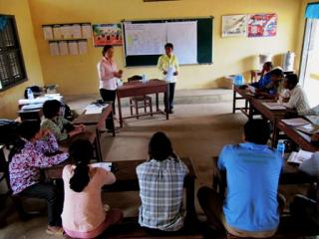Identify practical problems faced by the FWUC committee
* Get a clearer understanding about what the FWUC committee is supposed to do and to achieve
* Measure the gap between what the FWUC is doing and what it is supposed to do
* Define priorities for improvement
* Identify external supports needed
* Compare FWUC with each other

Through evaluation, the ISC aims at comparing FWUC, showing which ones get the best results, where farmers have a strong ownership and where government and development partners shall direct their supports. For example, the access to government subsidies or maintenance fund from government could be linked with a minimum level of management in order to ensure that the money would be used according to appropriate financial procedures and will truly benefit to the farmers.

## The evaluation committee

To organize and facilitate the evaluation process, the ISC set up an evaluation committee involving other institutions. This committee should be composed of around four members from:

* ISC
* Farmer & Water Net
* MOWRAM - FWUC Department
* Other project or donor agencies

They will not necessarily attend all evaluation sessions, as two facilitators are sufficient, but will share information together and validate the overall process, ensuring that the results are comparable.

## How to evaluate?

The evaluation is a participatory process: local stakeholders decide by themselves what the actual level of their FWUC is. They follow a specific framework, so that the results can be compared between The evaluation is done through the review of 33 pre-defined criteria.

These criteria cover the following nine thematics:

1. Scheme technical and economic performance
2. FWUC institutional organization: statutes, registration, membership, election, general assembly
3. Database
4. Service implementation: operation and maintenance, rules enforcement
5. Human resources
6. ISF collection
7. Budget and financial sustainability
8. Financial procedures and control
9. Coordination with other stakeholders, local authorities and MOWRAM

For each criteria, a detailed list of information is defined to be collected and analyzed before answering if the criteria is met or not. The facilitators ask detail questions to the participants for helping them understanding the criteria and checking what the FWUC do or don’t. It allows also the team to collect information about the scheme and FWUC.

Once the functioning is clarified, the participants can allocate a value from 0 to 4 to the criteria.

1. **Nonexistent** The FWUC doesn’t yet implement or consider this aspect
2. **Very weak** This criteria is already taken into consideration, but implementation is not satisfactory and the criteria fails.
3. **Ok but to improve** The criteria is met, but important improvements are still possible and needed
4. **Good** The criteria is successful and properly implemented, some improvement are possible, but not urgently needed
5. **Excellent** The criteria is met and the implementation is at a professional level

For each criteria, this value is represented by coloring a case on an arrow drawing.

11-04-27 Kouk Thnot evaluationb.tif

## The management levels

The criteria are spread between six management levels representing the overall result of the FWUC management for comparison with other FWUC. These levels are defined as below:

|  |  |  |
| --- | --- | --- |
| Level | | Description |
| O | **Not operational** | Irrigation is not (yet) available: scheme under construction or too damaged or not sufficient water resource available |
| I | **Partially operational** | Irrigation is at least partially available and there is some farmer management, but very low performance, no clear organization between farmers, or less than one year experienced. |
| II | **Institutional construction** | The scheme is managed by an active FWUC with clear membership and an elected committee, but management level is weak: the FWUC can ensure only the basic scheme operation. |
| III | **Basic management** | The FWUC operates the scheme and implements some emergency maintenance. The FWUC try to collect ISF, but the amount and the percentage collected are low. The FWUC organizes yearly village or general assemblies. |
| IV | **Experienced management** | The FWUC is experienced and collects ISF at a good level; it has a budget and a good financial management. It ensures a regular maintenance, but still insufficient on the long term. |
| V | **Expert management** | The FWUC is financially and technically autonomous and sustainable. Financial control systems are in place. Maintenance is sustainable over the long term. The FWUC has signed a responsibility sharing agreement (MoU) with MOWRAM. |

To reach one level, all the criteria belonging to this level and to the lower levels have to be met, so to get a value between 2 and 4. Even if only one criteria has a lower value (0 or 1), then the level is not reached.

## The steps

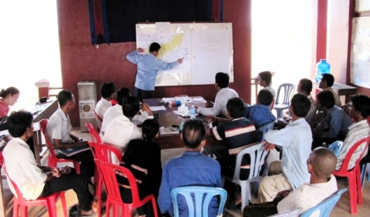The evaluation is organized in 4 steps:

**Step 1:** Explanation about the evaluation objectives and overall process;

**Step 2:** 2-3 sub-groups discussion (~5 people / group) to specify the value of all 33 criteria;

Step 3: Plenary session discussion between groups about each criteria value and discussions if the groups disagree about the value; progressive drawing of the arrow;

Step 4: Summary of the global result by the facilitator and final decision on the FWUC management level; discussions about priorities for improvement.

The main idea is to confront the point of view of at least two sub-groups:

* The first sub-group is composed with the farmers, members of the FWUC and village chief. They are the main users and they know the situation in the field closely. They may or may not have a good knowledge of the FWUC functioning.
* The second sub-group is composed with FWUC representatives, FWUC staff, commune officers and PDOWRAM staff. They are in charge of the management and know better the FWUC functioning, but sometimes they may overestimate the results of their activities.

Other sub-groups can be created with another composition if there are many participants and enough facilitators. Each group should be between 5 to 8 participants in order to allow discussions and exchanges. So the total number of participant shall not exceed 20, including the facilitators, for example:

* FWUC committee members (3-5)
* Commune chiefs (1-3)
* Village chiefs (3-4)
* Farmers (1-3)
* PDOWRAM staff in charge (0-1)

It is very important to compare the points of view from different stakeholders to give a fair picture of the management and also to appreciate how the information is circulating between the different levels of stakeholders. It can reveal as well some conflicts that authorities or representatives are keen to hide.

The overall duration of the evaluation should be between 3 and 6 hours, about a half day or a bit more. It is important to shorten sometimes the discussions to achieve the evaluation within the time frame to keep participants actives and avoid them to be bored or sleepy. Three hours is a reasonable duration for FWUC who have limited activities and procedures. Six hours will be needed for FWUC with higher level of management and a longer experience, especially if the collect the ISF and have a good financial management.

## Defining priorities for improvement

From the arrow, the participants can extracts easily which criteria are preventing the FWUC to reach a higher level of management. The participants can discuss and understand better what the main limitations are and which improvements should be prioritized. For example it is very difficult to go for ISF collection if there is no database available to know who should pay. The election of the committee cannot be done transparently if members are not registered and known. A logical process to improve the management over the short and long term, step by step can be established accordingly.

## Some limits for this evaluation methodology

* Based on the understanding and experience of local stakeholders (may hamper comparison with other FWUC)
* Not adapted for FWUC with limited or no activity, where there is only “infrastructures”
* Not all criteria are relevant for small FWUC based on farmers’ participation only, without formal organization.
* No criteria on popular issues for development agencies such as gender, environment (in order to keep it focused on the main practical problems)

Not all issues are considered: it should not replace a full detailed evaluation -> not adapted for “feasibility studies”

## The evaluation sheet



# Chapter 4: Agriculture follow up and rice production economic analysis





