IRRIGATION SERVICE CENTRE
KOMPONG THOM

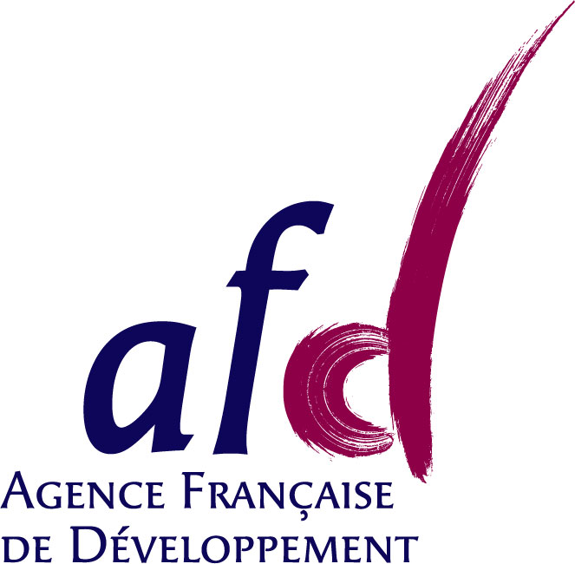
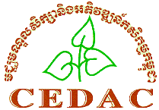
Project designed and implemented by and financed by

Minutes of the 3^{d} project management meeting

Attendance: Sophak, Sophat, Sophanna, Antoine
Venue: Phnom Penh office
5 February 2010
8:30 to 12:30

- Coordination Committee
Situation: Refusal from Chan Sinath to involve national level government services.
Sophat: CS probably thinks that it is a PMU like for other project. Some misunderstanding that we should clarify.
Sophanna: the name is confusing, Proposition: Advisory Board (to indicate that there is no decision making at this level).
Antoine: Let’s go forward in organizing something at Provincial level. Later on we can come back to the National level.
Proposal: organize a Coordination Meeting for Provincial Stakeholders in May 2010
Objectives:
- Explain the ISC mandate, that ISC is a private organism which work under contract
- Explain the purpose of the CC: coordination with authorities and donors, official support, advises and information about strategy and activities
- Get the approval of the people attending to become members of the CC
- Validate the CC TOR
Should we decide to call the CC: advisory board??
The opening ceremony is abandoned as such. We will organize something when the ISC is recognized and becomes an independent organization. (Not later than mid-2011)
- New staff recruitment
Ek Ren, previous SCIRIP facilitator has been recruited mid-january.
Agreement on the proposal made by Antoine after Sophak met with Sreyleak and Sem Sarath.
Recruitment of Srey leak has a GIS and database manager will be effective on Feb 10 and Sem Sarath agreed to join the team as a Community Trainer (position in between facilitator and engineer) after one month notice for his previous job.
Recruitment of one more facilitator (Ms. Kamnhan refused the job) will be discussed next week with the team (proposal Ms. Saron or M. Bunthoeun)

- Contract with CEDAC for Sophak
Agreement to sign the contract with 1st January date if a timesheet is sent to Antoine by Sophak (check that he worked full time for ISC).
Need to get information about leave entitlement for Sophak, and need to get a clear work plan for February.
CEDAC look at the document in details, if OK, ask signature from Koma and send it to GRET. If modification, send the new version to Antoine (& Patricia).
- Procedure and main steps to establish ISC
Request from Sophak to discuss more clearly with the ISC staff about the future of the ISC, especially in term of institutional organization
Decision: make one day meeting with the staff in Kg Thom, together with Sophanna and Sophat about this subject. Proposed date: Friday 26th February.
- Director ToR proposed by Piseth
These TOR are globally approved, but need some discussion with Piseth himself.
Piseth will participate to the Management Committee in the future (but no decision capacity)
He will sign the service contracts with local organizations (commune or FWUC). He has some capacity to approved expenses.
The main point is to improve Piseth capacity in term of meeting organization, report writing, communication. Some training should be identified (to Silaka or VBNK).
- Capitalization with IRAM – AVSF and internship
One student will be recruited from France for implementing this internship related to the capitalization between the three experiences. This internship will help the team to feed the data from Cambodia to other components.
Sophat is considering taking this opportunity to finalize his own thesis.
The student will come. Sophat can do some part of the work with the support of the project (but not internship fund). No problem.
Sophat and Antoine will meet to discuss the TOR for this internship.
- Activity report October to December 2009:
Not much comments.
Sophanna proposed that the ISC team should meet with World Bank and ADB. Sophat will provide a contact in World Bank (Khmer). Sophanna propose that Antoine participate to the coming workshop / annual meeting organized by M-Power, and may be meet with them on that occasion.
- Activity plan for January to June 2010
  - FWUC network, collaboration GRET - CEDAC
Common proposal between ISC and CEDAC:
Responsible Mr Sophak
Budget: 600 US$ per meeting x 4 /year from ASIrri + 2000 US$ from M-Power / 1 year.
It is about 1100 US$ per meeting, so we can enlarge the attendance and organize exchange visits.
Discuss the status of this network, including the membership
Proposal: full membership for FWUC who meet some quality criteria and learning or associated membership for FWUC who are new, learning and / or do not meet the minimum functioning standards.
Objective write a policy paper by the end of this year on access to the government maintenance fund and FWUC involvement in infrastructure rehabilitation or construction planning
Include more FWUC (Trov Kord with Human translation funding, etc.)
Sophanna: plan for CEDAC to establish this network officially next year.
  - Visit to Kampot
The team visited the irrigation site proposed for investment in Kampot. There are some information needed not available (reservoir capacity, irrigated area and canal needed, among other). We proposed to make a feasibility study, if the farmers pay for this study (at least part of the cost). The team will write a proposal to the farmers.
  - Service proposal with JICA-PRDNEP in Mondulkiri
There is a fund of about 25000 US$ available for FWUC establishment in one scheme in Mondolkiri. Sophak visited last week. The funds come from JICA through the provincial NCDD. The work need to be done between May and November. Sophak will write a proposal.
This contract should be managed as much as possible by the ISC team (proposal, budget and follow-up). It is important for the learning process of the team. It can mobilize other staff from CEDAC. However as the ISC has no official status yet other than project of GRET. Either CEDAC or GRET should sign the contract. The team will make a proposal.
  - Investment for other schemes
The investment fund is now very large and it is not recommended to use it for loan (risk with EU procedures and difficulty to implement). The rule is that investment fund is provided to enlarge funds already available locally from farmers or commune and on the condition that there is a service contract signed with the ISC.
We will propose investment (around 20,000 US$ for each one) in 5 Kompeah and in Stung Chinit North for this year. Strong interest from this last scheme
  - CEDAC support mission
TOR for the mission will be available end of February. The study itself could start in March.
  - Exchange visits
Sophat contacted with Takeo Pdowram. He likes us to visit 1 very good scheme: Phlov Tuk. To be organized according to work plan.

- Budget for 2010 to June 2011 with EU Food Facility
Quick review
- Workshop organization, participants
6 presentations are selected:
Piseth ISC (membership in 5 Kompeah), Kadum CEDAC (ISC collection), Phirun CDRI (relation between FWUC and local authorities), Kalyan NWISP (Apex committee formation for water resource management between schemes), Sok Touch private Takeo (issues of private contracts for irrigation management), Tong Heng TSC (experience of participation in Pursat pilot scheme)
A list of 90 participants is ready, to be reviewed.
Budget proposal 3400 US$, seems too much, need to limit to 80 participants (10% don’t come)
Date will be confirmed when room reservation will be done. (Hotel Phnom Penh propose 20 US$ per person with lunch and everything). Difficult to find cheaper. Sophak looks at it with Kunthea in CEDAC.
- Reflection Workshop on ISC goal, vision, mission and strategy
See point 4.
- Fix the date for the next meeting
End of May 2010, in Kompong Thom, half day in office and half day field visit.

