IRRIGATION SERVICE CENTRE
KOMPONG THOM

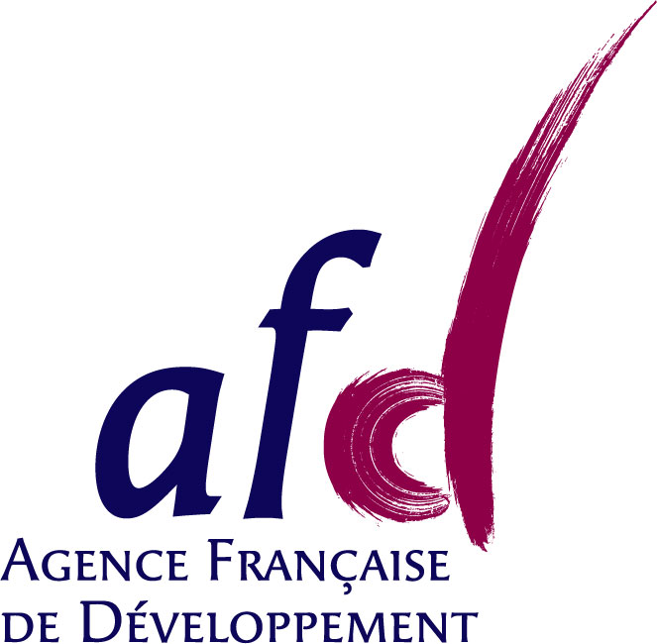

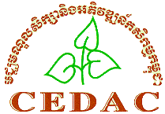
Project implemented by and funded by

Minutes of the 4th project management meeting

Attendance: Sophak, Sophanna, Antoine, Piseth (Sophat absent)

Venue: Kg Thom ISC office
25 May 2010

Morning:
- visit of Teuk Chha scheme (9:30 to 11:30)
- lunch in Teuk Chha with FWUC committee and ISC staff in charge

Afternoon:

- Coordination Committee
Even though the Coordination Committee could not be established as planned earlier, we should organize a meeting with the donors and concerned PDOWRAM to explain the project achievements and strategy after one year of implementation.
Proposed attendance:
- Donors: AFD (Sideth and Olivier), EU (Lea Jenin)
- PDWORAM of Kompong Thom (chairman) and Kompong Cham
- Provincial staff in charge of commune fund follow-up (NCDD) for Kg Thom and Kg Cham
- Technical Assistant in MOWRAM (Badre Lanedri)
- GRET rep. (Dr. Cédric Salze), CEDAC president (Dr. Koma)
- EU-FF coordinator (Solal Lehec) and M-E officer (Saravorn)
- The project management meeting members
The meeting could be held on 24th August 2010 in PDOWRAM Kg Thom.

- Activity report January to May 2010:
  - Service to Pram Kumpheak (Sophak)
- Participatory evaluation of the first service done (report to be written)
- Payment done (3 million KHR)
- New contract signed and under implementation (8 million KHR) to be paid by commune
- Infrastructure construction progressing well, plot measurement and database construction process is clarified
- Important to already plan the future ISF collection (part of service contract N0.3)
  - Service to Teuk Chha (Piseth)
- 2 contracts signed: one for the main canal (no payment) and one for creating a FWUG at secondary canal B level (7,4 million KHR paid by communes and FWUG)
- Recruitment of 4 water gate operators; 2 are paid by ASIrri FWUC investment fund, need to prepare a contract
- Set up of a Water Sharing Committee at main canal level chaired by PDOWRAM district staff
- Village meetings at canal B level finished, MF to be collected soon.
- Need to prepare procedure for cash for work that will be use to maintain the canals with FWUC investment fund
  - Service to Stung Chinit East (Piseth)
- 1 contract signed to set up a FWUG (8,4 million KHR paid by commune and FWUG)
- 50% MF collected up to now
- Important meeting with commune and NCDD staff to solve the problem of the future canal alignment and gate level (to decide if a new gate needs to be built, and if yes, where)
  - Service to Stung Chinit North (Sophak)
- 1st service finalized and paid, but not yet evaluation
- Under negotiation with AFD and MOWRAM a budget subsidy for next year of 29,100 USD. To be finalized before 15th of June. Not yet discussed the funding for maintenance. This support from ISC is not done under contract.
- Problem at the CRIC meeting who hasn’t validated the ISF increase to 40,000 KHR for this year. Sam Rainsy politicians are making trouble. May need some intervention from MOWRAM.
- To be prepared: a yearly contract of service delivery up to end of March 2011 with a fixed number of working days for ISC.
  - Service to Mundolkiri (Sophak)
- Need to finalize contract between GRET and CEDAC.
- First payment to ISC done (3,000 USD, trough Sophak)
- FWUC has been created, MF collected (83% collection for 178 ha, 33 families paid, 1 million KHR collected) and committee set up with agreed allowance by the GA. Member database and scheme map already done.
- Commune agree to fund the FWUC around 2 millions / year.
- Need to make the FWUC recognized by district and provincial authorities, to open a bank account and to implement training and exchange visits.
- Piseth in charge of preparing trainings with Sarath; may be could ask support from CADTIS (work for NWISP in Pursat)
  - Service to Sdao Kong (Antoine)
- Budget support asked from MOWRAM for 6,313 USD. Approved by AFD, but still to be discussed with Veng Sakhon – See report to MWORAM
- Need to negotiate a service contract for financial management follow-up
- Need to prepare a planning for the scheme rehabilitation (with EU-FF fund)
  - CEDAC mission results
- Presentation made on Friday 21
- Draft report available, please provide comments as soon as possible
- Final report will be provided for the 6th of June
- The same base line study could be carried out in Sdao Kong
- Need to prepare a short contract between GRET and CEDAC, before payment
- Activity plan for January to June 2010
  - FWUC network meeting
- Meeting on 25 March with 10 FWUC (11 participants)
- Report available in Khmer to be distributed to the members during the coming exchange visit in Siem Reap (26-28 May)
  - Other scheme identification
- The team is fully busy at the moment, but we have still to look at the possible extensions of the ISC activities: to Siem Reap (look at it during FWUC Network exchange visit), to Takeo (Sophat had a demand from PDOWRAM and we should support Kbal Po)
  - Next CEDAC support mission
- The idea would be to ask support from CEDAC to establish multi-purpose FWUC (not only irrigation management, but also saving group, marketing, etc.). Sophanna will discuss within CEDAC this idea.
- Internships
  - Fanny has 3 objectives:
    - Review the FWUC diagnostic procedures and database management
    - Study Pram Kumpheak and Teuk Cha FWUC organization and water management (accompany the team)
    - Describe the process of service provision by the ISC
  - Sophat: still negotiating his work. He will study the coordination between stakeholders: FWUC, local authorities, MOWRAM and others in Kbal Po, Po Pi Daem and Teuk Cha.
  - Future internship: to set up financial management services to FWUC. Need to recruit one staff. Thy from GRET should also support this internship.
- ISC institutional model and governance, steps to reach a proposal
It is proposed that we will ask an external mission (national expert) to study the ISC institutional model and propose statutes format and future functioning. The expert team could be composed of one lawyer and one institutional expert. They will review some other experiences for professional organization in Cambodia and meet all the concerned stakeholders.
We should work out some TOR for this mission to be discussed during the next Management Meeting.
Sophanna will look for national experts (VBNK?, other independent?), Antoine will see with ADG and GRET for some contacts.
The mission should be carried out in October – November in order to get a clear proposal end of December.
- Workshop results and next workshop
- Need to prepare a CD with all presentations
- Kanhnha already prepared the minutes of the workshop
- Need to translate 2 presentations (ask outsider to do it?)
- Next workshop to be planned for early February 2011. Some thematic proposed:
  - Multi-purpose FWUC
  - Role of Service Centre in supporting commune management of NCDD funds
  - Access to maintenance fund for FWUC (may be this subject should be kept at FWUC Network level)
- Fix the date for the next meeting
Between September 20-23, organize the visit of Pram Kumpheak scheme.

