KINGDOM OF CAMBODIA
Nation Religion King

Ministry of Water Resources and Meteorology

NORTHWEST IRRIGATION SECTOR PROJECT

 | ADB Loan No 2035-CAM (SF)  AFD Grant No CKH 3003.01

Integrated Water Resource Management and the FWUC APEX Committee in the NWISP

A presentation for the “Support to Farmer Water User Communities: Review of experiences and strategies” Workshop. Organized by Irrigation Service Centre (ISC).

March 2010

FWUC APEX Committee
Following site identification under the NWISP it became clear that adjacent to several subprojects selected for rehabilitation, there were other FWUCs sharing the same water source or main system control structures as the subprojects selected by NWISP. There are numerous subprojects in this situation in NWISP where there are up to 6 FWUCs organized along the main canal or river in the immediate vicinity and these 6 FWUCs impact upon each other in terms of water supply and availability (for example Po Pi Deum, Canal # 1) in the one subproject area.

The NWISP irrigation rehabilitation and FWUC development is implemented through service contracts with private companies who are paid to focus specifically on the subproject area and immediate beneficiary communities. This means that no work would be done in those shared, adjacent upstream or downstream schemes. The NWISP subproject beneficiary communities reported conflicts over water scheduling and distribution with these adjacent FWUCs thereby identifying an IWRM issue that needed to be resolved.

The bulk delivery of water is a service is provided by PDWRAM and must be effective within the restraints of water availability at source. That is, the main and conveyance systems must achieve a suitable level of operation and encourage farmers to adapt to different technologies and to take responsibility for their level of operation. Operations at main system level must ensure equitable distribution of water supplies to unit command areas, to enable the FWUCs to do the same at farm level and to develop satisfactory operation rules, i.e. the main and delivery system must be well designed and managed for the rest to work.
It became clear that rehabilitation of the NWISP subprojects may not improve the irrigation service significantly if the coordination of water sharing between these FWUCs did not improve. Without any improvement in service quality it is unlikely that the FWUC memberships would remain committed to sustaining the FWUC. MOWRAM did not have mechanisms for IWRM so, due to necessity, a means had to be found to link the FWUCs that share and compete for a common, limited water resource, and or, share system level control structures. It is referred to as the FWUC Apex Committee. This is a new structure that has been created following consultation within MOWRAM and the FWUC Department.

There is therefore a need for training, information dissemination and capacity building of users and entities that are not presently included in the scheduled programmes and are outside of the Service Providers terms of reference. There will be 4 different Apex Committees established under NWISP and this work will be done by the PDWRAM with assistance from Project TA.
The PDWRAMs have agreed that this is critical work and that the Apex Committees should be formed, and have accepted their role since they will be responsible for operations of main systems and water allocations also for areas that lie outside of NWISP sub-projects.
Roles
The Apex Committee that has been proposed will be chaired by PDWRAM who are also responsible for the O&M of the primary assets. The Apex Committees will comprise heads or deputies from the participating FWUCs. The PDWRAM will carry out the operations and maintenance of the main systems, the Apex Committee will manage water allocations, and the FWUCs will be responsible for the management of their respective command areas (secondary canal system). If the scheme crosses district administrative boundaries then PDWRAM representatives from both districts will participate on the Apex and the chair will go to the PDWRAM with responsibility for the headworks.
The Apex Committee structure is shown schematically in the organizational diagram, see Figure 1 below.
The main task of the Apex Committee is to act as an O&M coordinator. Another main function is the formulation of a system level irrigation service plan, being an agreement on a water distribution schedule between each of the FWUCs, based upon each FWUCs own irrigation service plan for water distribution at subproject level.
The Apex Committee also oversees implementation of O&M responsibilities between the FWUC and PDWRAM. In general, the PDWRAM would assume responsibility for operating scheme level structures (primary assets), and FWUCs will be responsible for operating structures at the subproject level (secondary assets).

Figure 1: Main System FWUC Apex

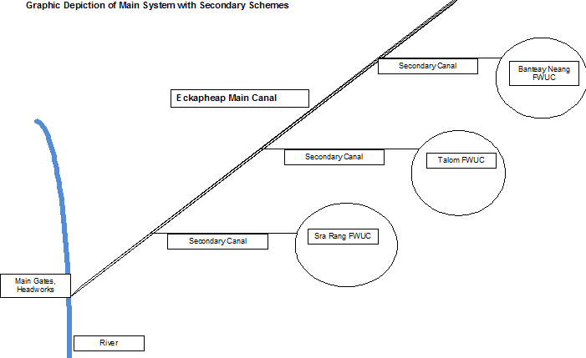

The Apex Committee therefore has an ongoing role in the supervision and provision of services to the FWUC. The Apex also has an immediate link back to the PDWRAM. Representatives on the Apex Committee must ensure that their respective organizations carry out their tasks and duties.

This link between the Apex Committee and the PDWRAM is illustrated below:

Figure 2: Apex Committee organizational relationships
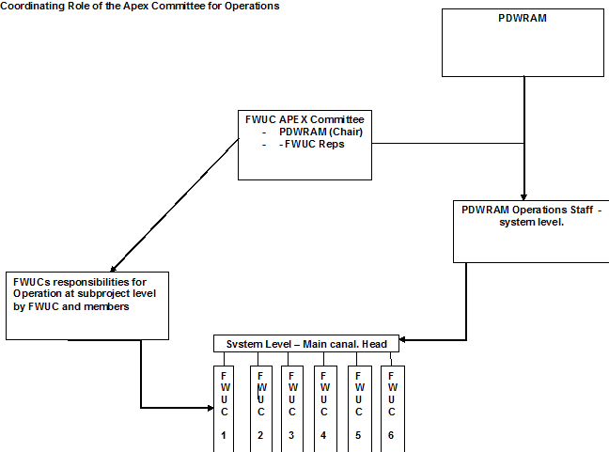
The PDWRAM representative on the Apex Committee has the responsibility to organize, coordinate and monitor the operations by PDWRAM at system level, through the PDWRAM office and staff. FWUCs similarly have an immediate link back to their own subproject FWUCs and must ensure that they are performing the O&M tasks adequately.
This proposal addresses the training and capacity formation required to establish Water Management Committees (Apex) and is limited to the training of FWUCs and capacity building of the PDWRAMs and associated entities.

APEX Committees - stakeholder Training REQUIREMENTS
The Five (5) following sub-projects located in the four provinces in the NWISP programme share water resources directly with other user schemes on the main or river system as shown in Table1. (Don Aov and Canal No. 1 will actually be in the same Apex as they are adjacent schemes – so 5 subprojects will lead to 4 Apex Committees).
NWISP sub-projects and water source
Subproject | System / resource share | Province
Po Pi Deum sub-project (Ekkaheap canal sub-command area) | Po Pi Deum Scheme | Banteay Meanchay
Kork Thnong | Takou (ECOSORN) | Siem Riep
Don Aov | Bavel System /Don Aov head command area | Battambang
Canal #1 | Bavel System | Battambang
Kreuch Saeuch | Damnak Ampil / Stung Kambot | Pursat
Training and capacity building will be required at PDWRAMs as well as FWUC level. This work and related funding may be considered part of the PIU operational work. The capacity building includes policy information dissemination and some technical training.
The Project through the PIUs, will need to undertake capacity building in each of the non-project FWUCs that will be represented on each Apex Committee. These FWUCs have been established by different organizations and under different procedures and with varying support. In the majority of cases these non-project FWUCs are weak and inactive.
The capacity building activities will not be the complete FWUC training curriculum as being delivered by the IETs, and due to budget and time constraints the focus will be on initial FWUC organization and service planning. Following the initial capacity building, representatives from the non-project FWUCs may be invited to participate in further technical training being conducted by the SP’s (within existing budgets and contracts).
The objective of the IWRM initiative is to get each FWUC sufficiently strengthened in order that they are able to form and implement a seasonal irrigation service plan, and can agree upon a watering timetable or schedule to deliver water to the different groups without conflict. The amalgamation of the various subproject plans will effectively become a system ISP.

Scope of Work
The Apex formation work will be implemented by PDWRAM who will :
- complete project and policy orientations on PIMD,
- explain the need for and role of FWUC members and management committee,
- review existing organization and, where needed facilitate the reformation (re-election) of each FWUC management committee.
- provide basic training in how to formulate a seasonal irrigation plan
- role and function and establishment of the FWUC Apex Committee,
- facilitate district recognition of Apex Committee
The PDWRAM will be assisted in this work by the NWISP TA, in particular with the training content. The TA will also be responsible for assisting PMO in monitoring and reporting and budget control, and in evaluating the results.
Prior to commencement of the Apex training and capacity building programme, the PDWRAMs together with IETs will be briefed and trained on the Apex formation work.
Capacity building of non project management entities requires community meetings to be held at district, commune and village levels. Once the initial work has been conducted, representatives from these non-core FWUCs will be invited to join the SP training in O&M and in ISP formulation, budget for this participation is included in the cost estimate.
The magnitude of the work can be appreciated by the number of villages involved as indicated in Table 2, and totalling an estimated 175. These are the communities that share water resources by province.
Table 1 Number of villages, FWUCs concerned
* or water user communities with shared water resource

