MINISTRY OF WATER RESOURCES AND METEOROLOGY
Support to Stung Chinit Irrigation and Rural Infrastructure Project
Scenarios to sustain the Farmer Water Users Community after completion of the project
Mr.Sébastien Balmisse, Advisor to MOWRAM
4/28/2008

A few months before completion of the project, this mission intends to propose different scenarios to MOWRAM and External Development Partners in order to support the Farmer Water User Community of Stung Chinit. Building on the conclusions of the report of Mr. Jean-Marie Brun (GRET, 2008), this report is proposing 4 different scenarios with the objective of building the institutional capacity of FWUC to sustain the management of the irrigation scheme. To develop the different options, it was assumed that ISF would gradually increase from its current level (5 US$/ha) to a threshold value of 17 US$/ha over the next 5 years. Therefore, all scenarios developed require a budgetary support to FWUC for the next 5 years, ranging from 46 000 US$ (or 4.6 US$/ha/year) to 540 000 US$ (or 54 US$/ha/year). This report is intended to support the decision over the level and kind of support that can and will be provided to FWUC over the next 5 years.

Introduction

Following the support mission implemented by Mr. Jean-Marie Brun in Stung Chinit, a “Roadmap towards FWUC autonomy” was proposed to the different stakeholders.

This document was discussed during the ADB/AFD supervision mission headed by H.E. Veng Sakhon, Secretary of State and Project Director, early April 2008. It was particularly noted that the relatively low level of ISF currently collected in Stung Chinit (20 000 riels/ha), as well as the limited production potentialities of the area were serious handicaps for drastic increase of ISF as proposed in the roadmap. Therefore, it was proposed to develop different scenarios of decreasing budgetary and technical support, based on different level of irrigation service provided to farmers by FWUC.

This report is presenting a synthetic note for each of the scenarios, summarizing:
- The objective set to FWUC
- The level of Irrigation Service targeted by FWUC
- The subsequent type of organization required for FWUC,
- The corresponding FWUC budget
- The financial support needed and its evolution
- An evaluation of the type and level of risks corresponding to each scenarios

More detailed information is presented in appendix on organizational and budgetary aspects of the different scenarios.

Preliminary notes
It is very important to note that these scenarios are intended to provide broad evaluation for supporting decision making. Even though, efforts have been made to closely collaborate with the project team in their elaboration, further adjustments might be needed on the details of the budgets. Furthermore, a round of consultation with the FWUC will be needed prior to any decision.

Synthetic presentation of results

All the developed scenarios are based on the following assumptions:
  - the maximum level of ISF that FWUC will be collected after 5 years is established at 17 US$/ha. The rate of ISF collection is set at 80% of the total area. These figures are based on comparison with experience in other similar schemes, even though the target ISF seems quite ambitious with regard to the current settings of agricultural production in Stung Chinit area. There will be a gradual increase over the next five years of ISF (annual increase of 3 US$/ha).
  - MOWRAM will ensure proper management of the reservoir, primary and secondary canals (SC). Indeed, the maintenance of the schemes as it was designed turns to be very expensive in comparison with the actual benefits of farmers. Therefore, a strong support from the Government will be needed to sustain the infrastructures, at least in the next 5 years, while farmers turn to more intensive agricultural practices, including dry season farming.

A first round of discussion with the FWUC committee and the project was held on 11th May 2008. The different scenarios were presented to the FWUC. Discussions aimed at collecting the views of farmers on (i) the hypothesis of scenarios, especially related to ISF level, (ii) the different scenarios developed and their implications in terms of reorganization of FWUC.

It was noted that farmers consider that levying an ISF of 17 US$/ha after five years is an ambitious objective. In a preliminary open discussion, farmers expressed that an ISF of 40,000 riels/ha (10 US$/ha) would be a realistic target. Obviously, they recognized that double cropping as well as the perspectives of increasing sale price of rice and yields would help to increase a bit the ISF.

During these preliminary discussions, farmers showed a preference for scenario 2, which would allow FWUC to guarantee a fair service to farmers. They expressed particular concern over the capacity of FWUC to levy ISF if the irrigation service does not improve in the coming cropping seasons.
Option 1

Objective
The FWUC is autonomous after 5 years (its budget is covered by ISF collection)

Level of service
FWUC is responsible for delivering irrigation water to the head end of Tertiary Canal  Farmers must organize themselves to bring water to the plots  Maintenance is limited to tertiary canal and block level | 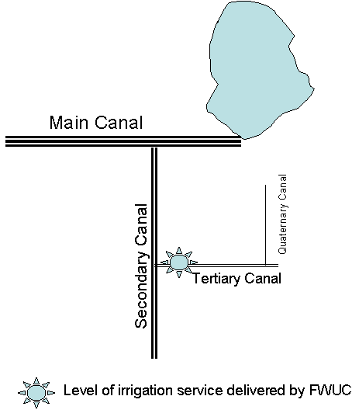

Type of Organization
- FWUC Committee members supervise the technical team and concentrate on representation and coordination issues
- A Team of 4 laborers headed by one technician undertake maintenance work at block level, ensure daily operation of the scheme and ensure that proper service is delivered at the head end of tertiary canal
- The role of Village Representatives is limited to representation of farmers in meetings and membership monitoring

Budget implications
Total Yearly Budget of FWUC: 27 015 US$

Financial plan
Total contribution from FWUC: 88 800 US$  Total external budget needed (for 5 years): 46 460 US$ | 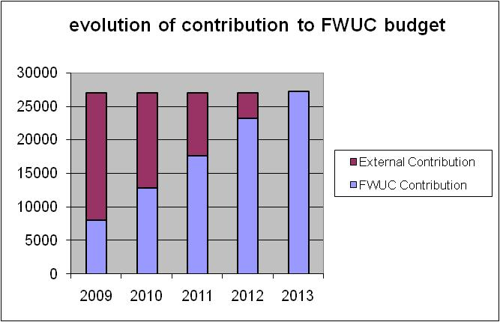

Risk associated
- Water is not adequately distributed along the Tertiary Canal and minimum maintenance is carried out (workload for technical team is very high). Blocks do not receive adequate discharge. The level of service at plot level is very low
- As a consequence of low irrigation service quality, a large part of farmers refuse to pay ISF
- Low rate of payment leads to the degradation of FWUC organization, and its incapacity to maintain properly the system
- FWUC members lose motivation due to decrease of incentives and low level of irrigation service delivered by FWUC

Level of risk: high

Option 2

Objective
The FWUC delivers a good service to blocks. After five years, there is still need for subsidizing a part of FWUC budget.

Level of service
FWUC is responsible for delivering irrigation water to the head end of each Quaternary Canal  Farmers must organize water distribution at plot level  Maintenance is limited to tertiary canal and block level | 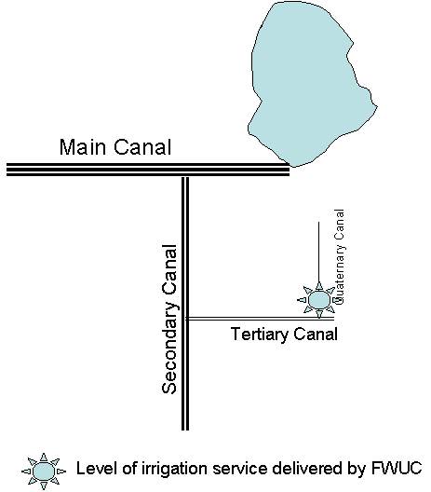

Type of Organization
- A Team of 5 laborers headed by one technician undertake maintenance work at block level
- A technical director is hired to supervise water management
- A team of Maintenance laborer is operational
- The role of Village Representatives is limited to representation of farmers in meetings and membership monitoring

Budget implications
Total Yearly Budget of FWUC: 43 560 US$

Financial plan
Total contribution from FWUC: 88 800 US$  Total external budget needed (for 5 years): 129 000 US$ | 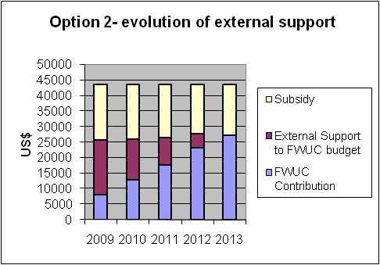

Risk associated
- Loss of motivation of FWUC committee members due to decrease in their incentives
- Some functions are externalized (accountancy, support to agricultural production,…) and will depend upon availability of competent service providers at a very low cost
- External support difficult to secure during and after the 5 years period

Level of risk: low during the first five years, medium if no external support after this period

Option 3

Objective
The FWUC delivers a good service to blocks. Emphasis is put on the continuation of ongoing institutional support to build a strong FWUC.

Level of service
FWUC is responsible for delivering irrigation water to the head end of each Quaternary Canal
Farmers must organize water distribution at plot level
Maintenance is limited to tertiary canal and block level

Type of Organization
- A strong and qualified technical team is built up, comprised of one 5 staff Director, 1 Maintenance Technician and 1 Operation Technician, 1 Village Facilitator and 1 accountant.
- A team of 4 Maintenance laborers is operational
- The role of Village Representatives is to represent farmers in meetings and membership monitoring, as well as weekly monitoring of scheme maintenance within their areas.

Budget implications
Total Yearly Budget of FWUC: 68 896 US$

Financial plan
Total contribution from FWUC: 88 800 US$  Total external budget needed (for 5 years): 255 680 US$ | 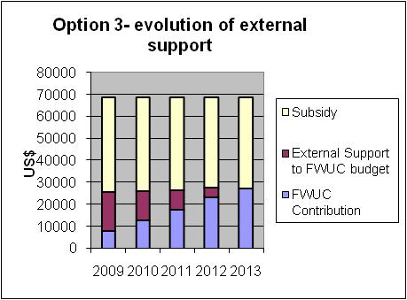

Risk associated
- FWUC remains very dependent on external support, high rate of subsidy jeopardizes its medium term sustainability
- The management of the FWUC is done by hired staff, there is few ownership by farmers
- External support very difficult to secure during and after the 5 years period
- Farmers reluctant to pay high salary large number of staff.
Level of risk: high
Option 4

Objective
The FWUC delivers a good service to farmers at plot level

Level of service
FWUC is responsible for delivering irrigation water to plots  Maintenance is limited to tertiary canal and block level | 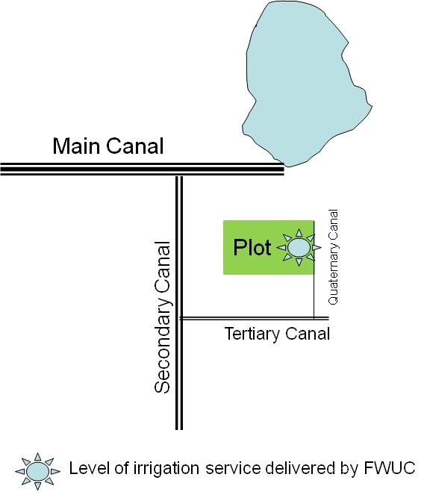

Type of Organization
- In order to deliver good service to plots, a team of 5 rangers is regulating water at secondary canal level, and 48 block rangers are hired at block level.
- A team of 4 Maintenance laborers is operational
- The O&M team is led by a technical director. An administrative Director and one accountant are responsible for the management tasks.
- The role of Village Representatives is to represent farmers in meetings and membership monitoring.

Budget implications
Total Yearly Budget of FWUC: 125 635 US$

Financial plan
Total contribution from FWUC: 88 800 US$  Total external budget needed (for 5 years): 539 375 US$ | 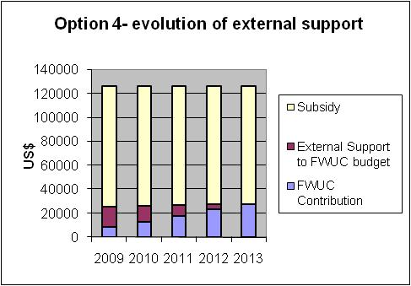

Risk associated
- This FWUC organization may be the only way to respond to original design of the scheme. However, it would require very high budgetary support. Such an organization would be highly dependent and its sustainability is considered as very low.
Level of risk: very high

Conclusions and recommendations
The objective of this report was to link the organization of Stung Chinit to the required budget in order to support decision making on the kind and level of support which is needed over the next five years. As such, the purpose here is not to provide any comment on which option is preferred, but rather to summarize the implications of the different choices that will be made.

Some comments on the different scenarios
Table 1 presents some aggregate figure concerning:
- The annual budget of FWUC for the various options described
- The external support that will still be needed after 5 years of initial budgetary support
- The percentage of subsidy required after 5 years to balance FWUC budget, which may be a good indicator of its level of autonomy;
- The total external support needed for the next 5 years of budgetary support.
 | Scenario 1 | Scenario 2 | Scenario 3 | Scenario 4
Annual Budget of FWUC | 27,015 | 43,560 | 68,896 | 125,635
Total yearly external support needed after 5 years | 0 | 16,360 | 41,696 | 98435
% of subsidy to FWUC after 5 years | 0% | 37% | 60% | 78%
Total external support needed during 5 years (US$) | 46,460 | 129,000 | 255,680 | 539,375
table 1- Aggregate figure for budgetary support to FWUC (options 1 to 4)
First of all, one should note that the complexity of Stung Chinit irrigation infrastructures induces high cost of operation and maintenance. Experience of the first seasons of system running shows that water distribution along the tertiary canal particularly requires some kind of supervision and organization. Similarly, maintenance costs are quite high due to the sandy nature of soils and to some extent due to low quality of some secondary and tertiary structures. Under these conditions, the sustainability of the scheme will bring about relatively quite high costs, as shown in the developed scenarios.

The scenario 1, reducing irrigation service delivered by FWUC to water distribution at head-end of tertiary canal, is in this regard a rather risky scenario, even though complete autonomy of FWUC reached after 5 years might look seducing. Reducing cost to the minimum may rather be a “fausse bonne idée” as it would jeopardize ISF collection from farmers which are not receiving irrigation water due to bad distribution at block level.

On the other hand, agricultural practices and agro-ecological settings observed in the scheme are somehow constraining the fast intensification of agricultural production. To substantially increase rice yields or diversify cultivated crops will require a constant agricultural extension support to farmers.

The hypotheses taken in this report seem therefore quite realistic targets to be achieved during the next support period if the adequate extension support is provided.

Scenario 2 focuses on delivering good irrigation service to blocks, by increasing the current team that will organize and supervise water distribution. There is a shift in the roles of FWUC committee members, who will focus on aspects linked to organizational management (ISF collection, elections, budget preparation, cropping calendar) and farmers representation (CRIC, organization of general assembly, collect of complains raised through Village Representatives…). This scenario is based on the hypothesis that external support will continue to be provided to FWUC in order to strengthen its capacity to carry out these tasks (by MOWRAM, private sector, FWUC service center…).

Scenario 3 emphasizes the strength of FWUC as an institution. By setting a strong technical team supporting a FWUC committee working full time, this scenario implicitly makes the assumption that survival of FWUC and its capacity to manage the system will depend on its organizational capacity. Largely inspired by Prey Nup project, this scenario requires rather high subsidizing, at over and beyond the 5 next years. Once the organization will be strong enough, some cost may be reduced as farmers may be in a position to take over roles played by technical team. However the forecasted level of subsidy to FWUC after 5 years (60%) shows a very level of FWUC autonomy.

Scenario 4 is based on the design of Stung Chinit Infrastructures. It mainly intends to enlighten the endless discussions going on between technical units of the project and the team in charge of FWUC on the costs of managing the system as it was initially designed and constructed. Delivering water to the plots requires a strong organization at secondary, tertiary and quaternary level, resulting in high costs for staff. Of course, one may argue that some of the tasks described in this scenario could be carried out on voluntary basis by farmers. However the experience showed that farmers, having plots outside the scheme and other non-agricultural sources of income, are not willing to spend the required time in the field that would enable smooth irrigation water distribution.

Maintenance of Secondary Canal: cost implications for FWUC
In the perspective of a future clarification of sharing of responsibilities between FWUC and MOWRAM, the 4 described scenarios were built on the hypothesis of MOWRAM being responsible of the maintenance of Secondary Canals (SC).

However, in order to have an idea on the additional cost induced by maintenance of SC, relevant budgets have been developed (presented as “bis” options in appendix) and aggregate figures are presented in table 2.

 | Scenario 1 bis | Scenario 2 bis | Scenario 3 bis | Scenario 4 bis
Annual Budget of FWUC | 37,140 | 52,310 | 79,296 | 133,635
Total yearly external support needed after 5 years | 9940 | 25,110 | 52,096 | 106,435
% of subsidy to FWUC after 5 years | 27% | 48% | 66% | 80%
Total external support needed during 5 years (US$) | 96,900 | 172,750 | 307,680 | 579,375
table 2- Aggregate figure for budgetary support to FWUC (options 1-bis to 4 bis, including cost of maintenance of SC)
Table 2 clearly shows that FWUC will not be in a position to cover the cost of operation and maintenance of the scheme (from II^{ry} to IV^{ry} level) whatever the chosen scenario.

In finding a path to sustain the management of Stung Chinit scheme, the FWUC should take into consideration its own capacity to levy sufficient funds from ISF to carry out this additional responsibility. A clear choice is necessary in sharing the responsibilities over Operation and Maintenance with the Government.

Complementary support needed

In the first two scenarios, it is assumed that in addition to the budgetary support, FWUC will receive external support. Indeed, a number of tasks are externalized, e.g. accountancy, high level technical director. Experience shows that, as the budget of FWUC and its responsibilities will increase, these organizational tasks become more and more important and require qualified staff to be performed.

A common pool center of support services to FWUC would be one option to enhance access to such external services, as described by Jean-Marie Brun. Such service centers would efficiently complement the action of MOWRAM to support institutional capacity building of FWUC. Such mechanism would however require high financial support, at least during the first 10 years, as very seldom FWUC can afford to have access to paid services nowadays in Cambodia.

It is proposed to raise ISF from 20,000 Riels to 100,000 Riels per ha in 5 years by a linear increase of 20,000 Riels/ha/year.
30 half days of work per month for FWUC committee members
Rounded figure, detailed budget and responsibilities of FWUC in appendix 1
Rounded figure, detailed budget and responsibilities of FWUC in appendix 1
This option is the one developed by the project after the last mission of Mr. Brun
Rounded figure, detailed budget and responsibilities of FWUC in appendix 1
Rounded figure, detailed budget and responsibilities of FWUC in appendix 1
ISF rate in 2013: 17 US$/ha and collection rate: 80%
Jean-Marie Brun, February 2008. Support to Stung Chinit FWUC overall management and post-project preparation. P.15-16

