■ mission report
ASIrri : support services to water users community

October 2009

Groupe de recherche et d’échanges technologiques
211-213 rue La Fayette 75010 Paris, France
Tél. : 33 (0)1 40 05 61 61 - Fax : 33 (0)1 40 05 61 10
gret@gret.org - http://www.gret.org

Groupe de recherche et d’échanges technologiques
Campus du Jardin tropical, 45 bis avenue de la Belle Gabrielle
94736 Nogent-sur-Marne Cedex, France
Tél. : 33 (0)1 70 91 92 00 - Fax : 33 (0)1 70 91 92 01
gret@gret.org - http://www.gret.org

Background
Since the end of the nineties, the Royal Government of Cambodia has initiated a policy to extend irrigated agriculture as a mean to cover food security and to alleviate poverty in the country. This policy is translated into the construction of new infrastructures and the rehabilitation of old irrigation schemes with the financial and technical support of external donors.
Besides the development of large schemes, more farmers are investing in small irrigation with pumping from rivers or drills. This kind of irrigation system is limited to farmer with good investment capacities and to areas with adequate water resource (permanent stream or shallow groundwater of sufficient capacity). These conditions are rarely found and the large majority of Cambodian farmers (80%) still depend on rainfed lowland rice cultivation during the monsoon season. Irrigation would be available only for about 20% of the country rice growing area. Actually, about half of the irrigation schemes identified are either not functioning at all or have a very low performance. This result is linked to the poor condition of infrastructures and, as well, to inappropriate initial designs.
The operation and maintenance of irrigation schemes require FWUC to undertake the following general functions:
- Water management,
- Maintenance of infrastructures,
- Irrigation Service Fee collection,
- Institutional and financial FWUC management.
Looking into details, the proper implementation of these major functions requires a large variety of tasks and skills such as engineering, design, preparation of bidding documents, topography, accounting, financial auditing, information management, database and legal advise, amongst many others. Not all of these skills can be learnt by the farmers and not all of them are required permanently.
Depending on the scheme size, different organizational options could be proposed from the very small FWUC (village level) who may not need a very professional organization to the very large ones who will choose the option of professionalization, with more salaried staff, and will be able to internalize more specific functions thanks to scale economies. For example, Prey Nup PUC has its own accountant, manages a database of land owners and plots, has staff skilled to implement topography work, prepare bidding documents or monitor works, but still need to externalize functions such as auditing. In between, the limits between internalized and externalized functions have to be defined for each specific case.
For externalized functions, existing commercial service providers do not always provide ad hoc services and/or are not affordable for FWUCs (e.g. an annual audit of accounting and finance, provided by a local certified accountant company, cost from 1,000 to 4,000 USD). From his side, PDOWRAM / FWUC department is mainly involved in the phase of creating FWUC, providing them with legal recognition and offering basic training in management. Its intervention is limited in time and scope. Our conclusion is that there is room (and need) for the development of alternative service providers and to strengthen links between FWUCs and existing service providers.
The main objective of the project would be to allow FWUC to access services which are:
  - Good quality, professional services,
  - Adapted to their particular needs and to their stage of development,
  - Affordable,
  - Sustainable
To reach this objective, GRET / CEDAC with the support of AFD propose to set up a pilot Service Centre in Kompong Thom province because Stung Chinit FWUC requires further support and there are a significant number of other small and middle sized irrigation schemes in this province.
The Service Centre should get advantage of the experience gained by GRET / CEDAC local teams involved in Prey Nup and Stung Chinit to propose services fitting the FWUC needs and allowing them to manage their scheme in a sustainable way.

Terms of reference of the technical support mission
- Review of activities planned
- Review planning for next year
- Economic model
- National workshop
- Exchange with other platforms
- Articulation with the transversal component

Review of activities planned

Institutional agreement
ASIrri received the authorisation from Mowram to carry out the project. Then Mowram gave directives to Pdowram to draw a MoU with the project. It has been signed the 6th of October.
Obligations towards Pdowram are : (i) monthly activities report, (ii) validation by Pdowram of schemes selection.

Human Resources
Since July all the team is fully operational. The team comprises besides the project coordinator :
- Institutional expert
- Operation and management expert
- Hydraulic Engineer
- Administrative assistant
- Two village facilitators.

The project objective is that the Irrigation Service Centre (ISC) will be viable beyond project length (3 years). As the international coordinator is there for two years at half –time, the centre needs a full time director who is ready to invest in the long term.
Amongst the staff, one expressed the willingness to step in this position. Project can accompany this person to get the necessary managerial skills to lead the ISC. The topic was discussed during the management committee meeting. Finally it was decided to make a proposal and set up a training program.

Activities carried out
- Two management committee meetings were held
Technical support mission assisted at the second meeting.
- Service offer
For the moment there are two kind of FWUC :
  - FWUC like Prey Nup and Stung Chinit. They have a functioning committee, raise funds and manage the scheme by themselves. They are able to identify the services needed by ISC that develop them accordingly
  - FWUC that have legal status but are not operating
Activities implemented
  - Service to Prey Nup : preparation of election (last fee collection : 75%)
ISC supported PN CUP in the election preparation in reviewing procedures and training committee members and candidates : election committee (chairman election, training members), recruitment of observers, necessary reports list, training of candidate, code of ‘conduite’, procedure for a candidate, election campaign.
The next service PUC might request is about training the auditing procedures committee and later about conducing an external financial audit. CER mission could write ToR for a trainee on the subject or design some procedures to follow.
  - Service in Kompong Thom and Kompong Cham
After the first assessment of 20 schemes in both provinces, ISC selected 8 sites (table in annex) where they intend to carry out detailed studies in order to formulate a service offer. Today, ISC is intending to sign their first service offer contract with Pram Kompeah. See in annex the minutes of the last meeting with 5 Kompeah village chiefs in order to talk about the service offer. (see annex). Other detailed studies are ongoing and other service offers will be developed.

ISC context
Challenge of ISC is offering services to FWUC while these last ones barely exist. This is the reason why ISC is selecting sites and is not waiting for FWUC to come over and ask for services. Generally speaking FWUC are not operational, are not collecting any money for water fee and infrastructures are just deteriorating. In cases FWUC committee is needed the first step is to re-organise it and also to raise funds to have financial means to the committee to function and manage the scheme. Sometimes, the commune is in charge of the management and there is no need to re-organise a FWUC
To give some incentives, FWUC creation could be followed by a scheme rehabilitation financed by FWUC own funds, Communes (through decentralisation) and ISC funds for rehabilitation.
When FWUC functioning is ensured, ISC could later on provide services for other matters like maintenance/water operation.
FWUC re-organisation is a compulsory step in order to get organisations that will be able in the future to access services from the centre.

Tools developed

First assessment survey
Detailed survey form
Map

ISC Funding possibilities

- Through communes by helping them to get access to the decentralisation funds put in place at province level.
- Through projects having funds to create/strengthen the FWUC like CAVAC or ADB.

Communication
Different tools have been developed like :
- Logo

- Website on CEDAC website.
- Leaflet (presenting the project)
- T-shirt

planning for next year
As the project is functioning with a team full time since July, project has to face some delays. The planning was reviewed according to the last findings and progress in the field.
As the MoU is signed now with Pdowram, his director with ISC support will organise the first coordination meeting. It is planned to occur in December and ISC will take this opportunity to organise its opening ceremony.
The planning includes all activities planned in the bi-annual report the next 6 month.

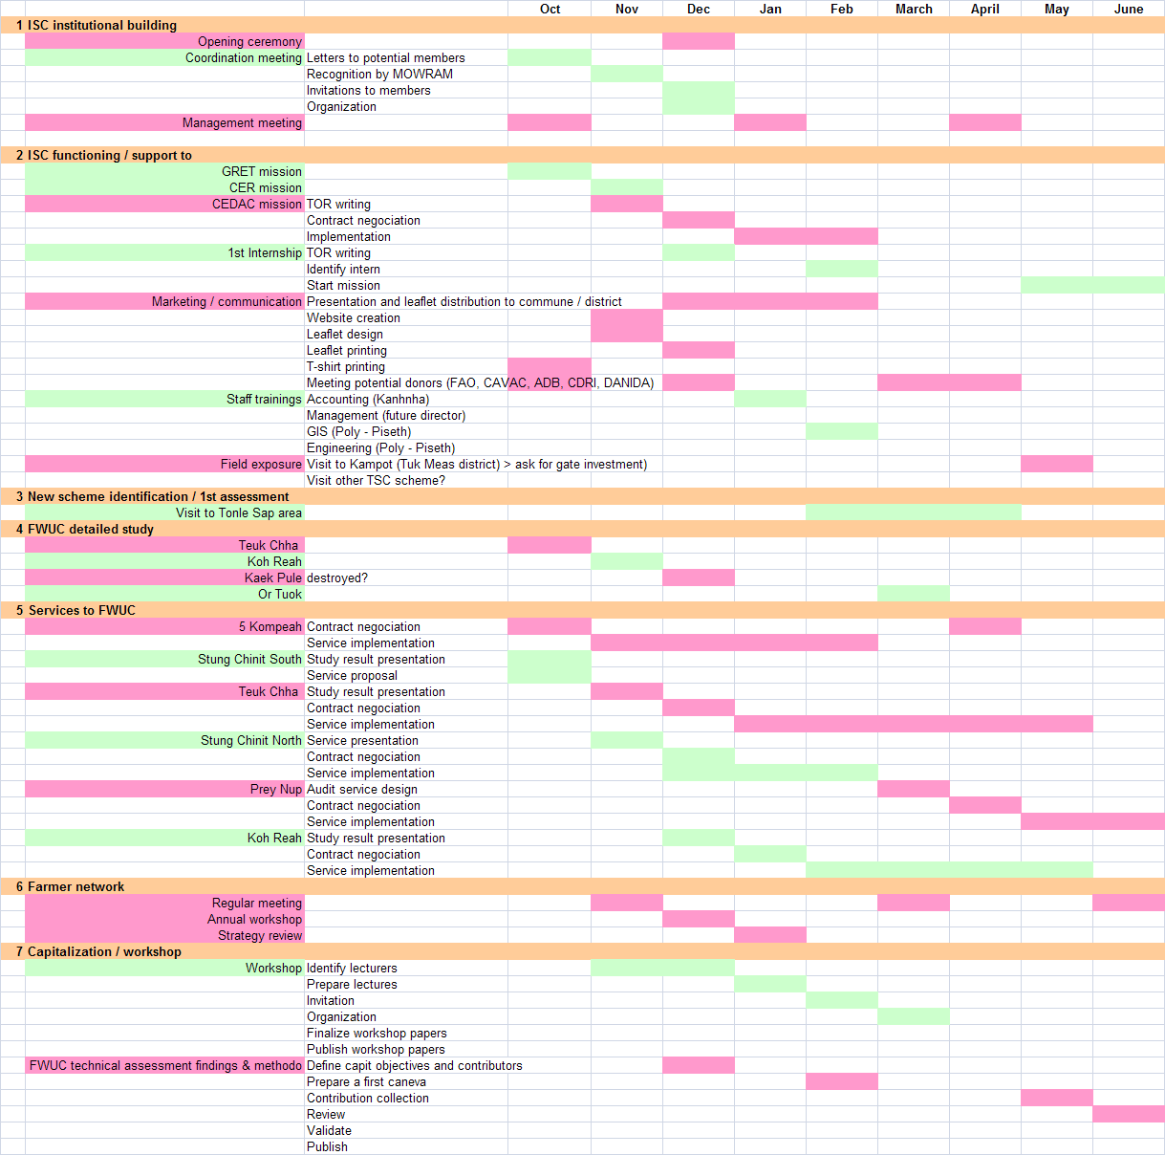

economic model
Team started working on an economic model according to their expected cost. In this model it is foreseen to have two different rates. In case ISC is working with FWUC, services rate is subsidised. Actually it is not possible to charge farmers in the current context at real cost. However, the second rate is foreseen for services paid by international projects for FWUC creation and/or strengthening and included human resources and running cost.
The model so far showed that even in the best conditions, ISC won’t be financially autonomous within 3 years and will still need support afterwards. This situation was foreseen from the beginning.
CER mission will be an opportunity to work more in details on the model developed so far.

national workshop
Workshop was supposed to be held in October but due to the slow start (full team operational in July) it will be reported in March. The second one will be scheduled in October next year, catching likewise the delay.
The subject this year is : ‘Experience to work with FWUC’. The idea is to collect experience from the field about a specific subject (fee collection, maintenance work, water management,..). Different organisations have been identified demonstrating an operational role in FWUC support and that could present their experience to the workshop participants. Amongst them : TSC (Technical Service Center), CDRI (Cambodia Development Research Institute), FWUC department, FWUC representatives, ECOSORN, private operators.
The workshop program will consist of case study presentations followed by a round table. After each presentation, participants will get the opportunity to ask questions and make comments. A team will take minutes and highlight the main issues discussed.
Team is starting now to contact people and explain case study presentation content.

network with other platforms
CEDAC through M-POWER (Mekong Program of Water Environment and Resilience) is supporting a FWUC network. Different meetings took place during the year and a workshop will be organised at the end of the year. ISC will attend and consider in which way it could play role in the facilitation of these meetings.

articulation with transversal component
The consortium IRAM-GRET- AVSF decided to change the annual workshop including the three projects into project exchange visits. The proposal was shared with the team and AFD in Cambodia. The institutional expert and O&M expert have been identified to take part of it.
  - .
Progress in Five Kompeah (5th of February) (see in annex)

ISC team did the first assessment, detailed study and presented the results in front of the villagers (September 2009). They recognized the good analysis done by the team. The service offer consists of : (i) re-creation of two FWUG (one group for 3 villages) under the umbrella of existing FWUC, (ii) scheme rehabilitation. Some village chiefs were not convinced that service offer could work out due to the villager reluctance to invest in the scheme infrastructure.

Team took the opportunity of the monthly meeting at the commune with all village chiefs to discuss again the service offer (meeting in Lovea Leu commune, Chamkar Leu district, Kompong Cham Province).
The main problem faced during the meeting what the fact that service offer included money collection. Village chiefs were saying that they were able to raise the amount but they were not sure that farmers who get already water will contribute. The commune is the only one legitimate to put pressure on them. The issue here is that famers who have water today have to consider the infrastructure for the community where each one has right to get water (in the limit of the command area and reservoir capacity). The infrastructure was not built only for them. The service does not aim to take out their right to water but to share it with the other farmers of the scheme.
For the others a letter explaining that in case the operation is successful the commune and the ISC committed to give money for the rehabilitation should convince them that the service offer is real and therefore to participate. This first collection of money is not ISF but membership fee that will give the right to take part of the decision process for the rehabilitation and the FWUC functioning. This is not compulsory.
ISC team explained also the need to collect an ISF in order for FWUC to function and to be able to take on maintenance and operation activities in the long term.
They proposed to start the collection and if an insufficient number of people become member, they stop everything. The system of money collection will be transparent. Confidence of farmers has to be restored on this issue.
ISC agreed to be paid at the end only if the service is satisfying.
At the end of the meeting it was decided to sign the service offer contract.

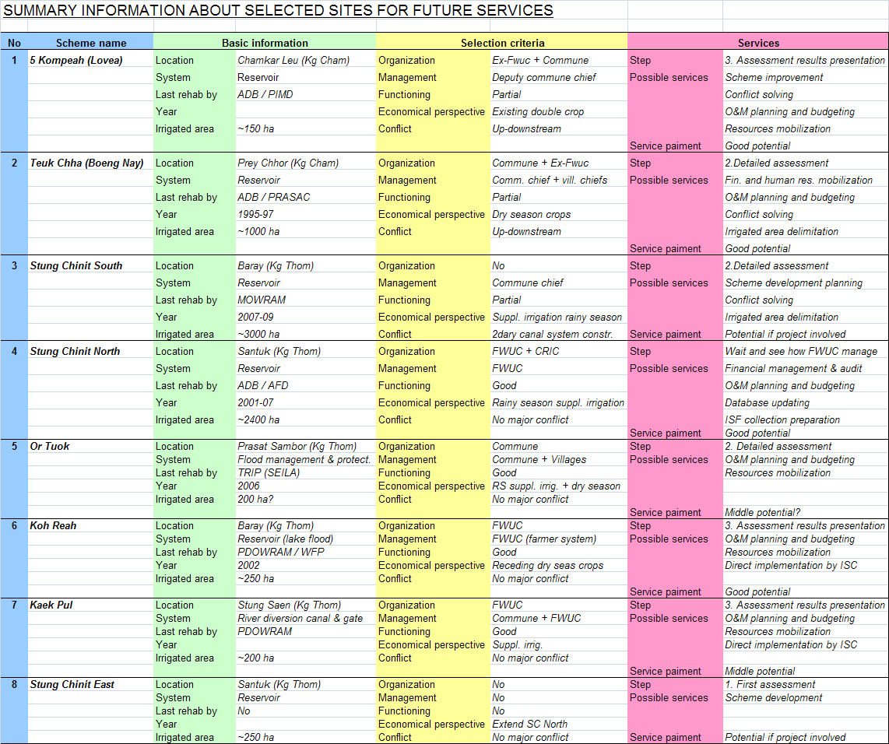
Appendix 1 : planning October 2009 to June 2010

