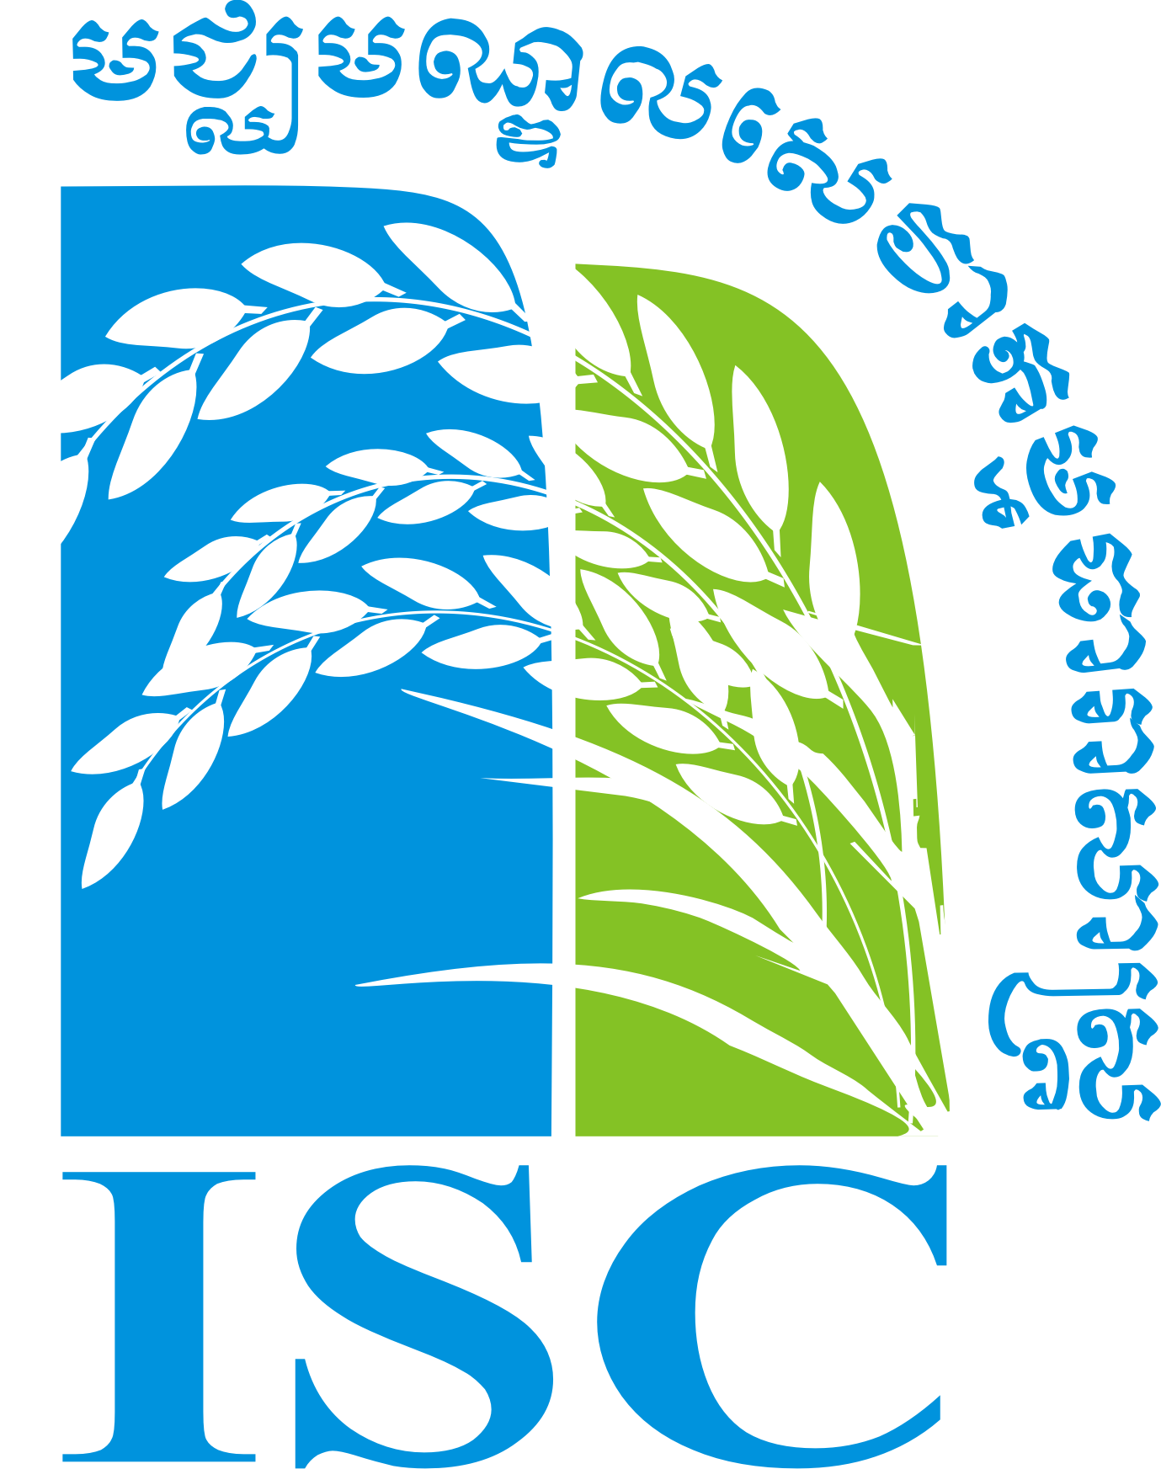

IRRIGATION SERVICE CENTER

Workshop
“Support to Farmer Water User Communities:
Review of experiences and strategies”

25th March 2010
Phnom Penh Hotel

Organized by the Irrigation Service Centre

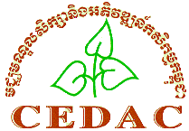With support from GRET and CEDAC

With funding from AFD
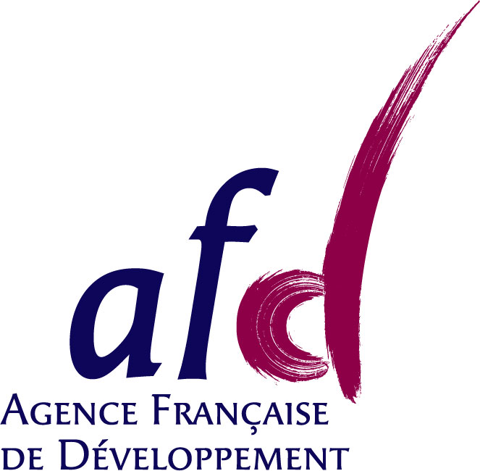

Venue: Phnom Penh Hotel
Thursday 25th March 2010

The workshop will provide a review of various experiences from different organizations working on improving irrigation scheme management in Cambodia. Presentations and discussions will look at how to improve FWUC capacities to manage their schemes by involving their members, collecting local resources, linking with local authorities and government service, but also by developing the private sector investment and sharing the water resource in a coordinated way in order to avoid conflicts.

This workshop aims principally to offer an opportunity for field staff either from government or private institutions and FWUC leaders to get new ideas and share their views. All the presentations and discussions will be in Khmer language to allow them to feel as comfortable as possible and encourage their participation in discussions. However policy makers, donors, public and private institutions interested with new ideas are most welcome as well.

Program:

7:30 | Registration
8:15 | National anthem
8:20 | Opening speech by M. Cheat Sivutha (PDoWRaM, Kompong Thom)
8:30 | Workshop presentation by M. Sophat (ISC advisor)
8:40 | Presentation 1 + questions and discussions
 | “Developing FWUC membership, the experience of ISC in 5 February scheme in Kompong Cham” by M. Long Piseth from ISC
9:30 | Presentation 2 + questions and discussions
 | “Organizing farmers’ participation for O&M, the experience of TSC in Thlea Mam scheme in Pursat” by M. Tong Heng from TSC – MoWRaM
10:20 | Coffee/Tea break
10:40 | Presentation 3 + questions and discussions
 | “Collecting the irrigation service fee, review of experiences” by M. Y Kadum from CEDAC
11:30 | Presentation 4 + questions and discussions
 | “The importance of coordination between FWUC and local authorities, review of experiences” by M. Phirun from CDRI
12:20 | Lunch break
14:00 | Presentation 5 + questions and discussions
 | “The risk of private investment and the difficulties for contracting, the experience of Kbal Po scheme in Takeo” by M. Sok Touch, private investor
14:50 | Presentation 6 + questions and discussions
 | “Sharing water between FWUC, the experience of Apex Committee formation” by Ms. Ly Kalyane from NWISP
15:40 | Coffee/Tea break
16:00 | Short reflection: “Why developing services for FWUC?” by M. Sophak, ISC institutional advisor, CEDAC
16:15 | Round table cession:
 | Reactions from the guests to the presentations
17:00 | Questions from the assistance and discussions
17:30 | Conclusion speech by M. Sophanna, CEDAC

